Technical assessment for……

Net Zero Buildings

Draft 1.1 , 18th December 2016

**Prepared by:**

David Mead

PROJECT**DRAWDOWN**

27 GATE 5 RD., SAUSALITO, CA 94965 [info@drawdown.org](mailto:info@drawdown.org) [www.drawdown.org](http://www.drawdown.org)

Table of Contents

Executive Summary 1

1 Literature Review 2

1.1 State of Net Zero Buildings 2

1.2 Adoption Path 10

1.3 Implementing Net Zero Buildings 15

1.4 Advantages and disadvantages of Net Zero Buildings 16

1.5 Net Zero Building Archetype 20

2 Methodology 23

INTRODUCTION 23

2.1 DATA SOURCES 24

2.2 ADOPTION SCENARIOS 25

2.2.1 BUSINESS-AS-USUAL 25

2.2.2 OPTIMISTICALLY PLAUSIBLE 25

2.3 CLIMATE AND FINANICAL IMPACTS 28

2.3.1 FINANCIAL INPUTS 28

2.4 ASSUMPTIONS 30

2.5 LIMITATIONS / FURTHER DEVELOPMENT 31

3 Results 32

4 Discussion 35

5 References 36

Figure 1 –Average Annual Change in OECD residential sector energy consumption, 2012-40 (% per year) 3

Figure 2 –Average Annual Change in non-OECD residential sector energy consumption, 2012-40 (% per year) 3

Figure 3 – Urban Residential Building Floor Area Distribution in China 5

Figure 4 –Net Zero Walgreens 6

Figure 5 –Bullitt Center 6

Figure 6 – Tighthouse – Passive House 7

Figure 7 –Rice Fergus Miller Office – Automotive Building Renovation 8

Figure 8 – Map of Net Zero Buildings Worldwide 8

Figure 9 – Map of Net Zero Buildings in the USA & Canada 9

Figure 10 – EU timeline for achieving NZEB 10

Figure 11 – The 2030 Challenge Energy Reduction Targets 11

Figure 12 – Meeting the 2030 Challenge 12

Figure 13 – AIA 2030 Commitment – Global Projects by gross square feet 12

Figure 14 – AIA 2030 Challenge – Record of International Net Zero Projects 13

Figure 15 – AIA 2030 Challenge – Percentage of Projects Meeting the 60% Energy Reduction Target 13

Figure 16 – AIA 2030 Challenge – Average pEUI Reduction by Project Use Type 14

Figure 17 – In contrast to hybrid cars, Passive Houses arguably are a step back to greater simplicity. Via Albert, Righter & Tittmann Architects 15

Figure 18 – Example of an Energy Performance Certificate in the UK 16

Figure 19 – 2012 CBECS – Percent of Surveyed Building Area at Different Stories 17

Figure 20 – Kaupuni Village – Net Zero Energy Affordable Housing Community in Hawaii 17

Figure 21 – Kaupuni Village – Net Zero Energy Affordable Housing Community in Hawaii 18

Figure 22 – Kaupuni Village – Net Zero Post Occupancy Performance of Homes 19

Figure 23 – Meritage Homes – Net Zero Revolution Ad 20

Figure 24 – Global Building Area Projects by Source 24

*Figure 25 –* *Business as Usual Emissions Growth compared to the ETP 2016 6 degree scenario.* 25

*Figure 26 –* *AIA 2030 Challenge – Cumulative Area of Projects Meeting the Architecture 2030 60% Energy Reduction Target* 26

Figure 27 – AIA 2030 Challenge – Percentage of Projects Meeting the Architecture 2030 60% Energy Reduction Target 26

*Figure 28 – Cumulative LEED Platinum Building Area* 27

*Figure 29 – NZB Projected Building Area* 28

*Figure 30 – Additional costs for nZEB buildings in the EU* 29

Figure 31 – Cost Deviation of nZEB buildings in the EU 29

Figure 32 – Cost Deviation by technology and quality of construction for nZEB buildings in the EU 30

Figure 33 – Global Adoption Scenarios (as square meters) for Net Zero Buildings 32

Figure 34 – Global Emissions Projections for Net Zero Buildings 34

Figure 35 – Global Emissions Savings from Net Zero Building Adoption Scenarios (Million Metric Tons of CO2e) 34

# Executive Summary

Net zero buildings (NZB) are a relatively new concept that has gained widespread awareness within the building industry. Though the building industry is very familiar with the concept the wider public is not that aware of the idea but it is growing. Net Zero refers to buildings which are either “net zero energy” or “net zero carbon”. Net zero *energy* buildings are energy efficient buildings which consume zero energy (in net, on an annual basis), meaning all the building’s energy needs are supplied through on-site renewable energy. Net zero *carbon* buildings are buildings which produce zero carbon emissions (in net, on an annual basis). The definition of zero carbon varies across countries and may include carbon offsetting.

For the purposes of this analysis net zero buildings are considered net-zero site assuming all of the energy consumed is offset by renewable energy generated on-site. In this way they should essentially be net zero source and carbon but this is dependent upon energy sources used to offset lower renewable output in the winter months. The analysis also uses the architecture 2030 challenge as a basis for policy adoption looking at its target reductions up until 2030 when all new buildings are to be net zero. Renovations have a target to reduce energy usage by 50% in the same timeframe but these have not been included in these results.

The functional unit in the calculations was square meters as was the implementation unit. The building area calculations were based on both Navigant and the Global Building Performance Data (GBPN) data. NZB performance is expected to save energy in buildings globally. According to the calculations completed, the NZB solution has the potential to reduce building emissions (when projected to 2050) from 4.82 to 31.87 GT of CO2 depending on the adoption rate society chooses to implement.

Multiple adoption rates have been projected for the solution from extremely optimistic to very realistic. The 2030 challenge sets performance targets but actual adoption has been lower than hoped as documented by the AIA 2030 commitment data. This is the data that has been used for a plausible adoption rate for this solution. In addition to this, LEED Platinum project adoption rates have been used as a proxy along with actual NZB adoption rates.

The results included in this report used a methodology that varies from the Drawdown RRS model. The methodology was established to set the ranges of impacts for NZB projects when looking at different area projections and adoption rates. It should also be noted the results are not being added with other Drawdown solutions as it is inevitable NZB projects will have many of Drawdown solutions included in them – this was done to avoid double counting. The results can be used to compare combinations of other solutions and as a policy framework for the building industry to strive towards.

# Literature Review

## State of Net Zero Buildings

The building industry has the potential to have a large impact on drawing down greenhouse gas (GHG ) emissions. There are many different energy efficiency strategies to reduce the impact of buildings. In addition to this, on-site energy generation takes buildings a step further to reduce their impacts. The ideal solution combines both of these strategies with buildings generating as much renewable energy as they consume on an annual basis. This is the essential concept of net zero buildings (NZB). Though there are a number of different definitions for NZB this is the core idea. In this way, the concept combines many other drawdown solutions into one elegant concept for humans to strive towards.

In practice, NZB helps drive design teams and owners to design and make investments in energy conservation measures (ECMs) and on-site energy generation. In this way NZB is a concept to drive change more than a specific technology. It is much more compelling for someone to say their building is Net Zero than that it is 47% better than a baseline building of similar construction. Without a clear goal it is far too easy for people to give up when design and budget restraints get tough. NZB offers this goal for society to strive towards. Ideally every new building could achieve NZB status but in practice it is far more challenging.

The World Green Building Council (WGBC) has recently established long-term targets including an NZB target that all new buildings and major renovations are net zero in 2030, and no buildings are built below net zero standards beyond 2030; 100 per cent of buildings are net zero by 2050; 75,000 professionals are trained on net zero building by 2030, and 300,000 professionals by 2050; and all GBCs operating certification schemes have net zero rating tools in place by 2030.[1]

**NZB New Construction Versus Renovations**

Achieving net zero is much easier for new buildings than renovations. Much of the work required to achieve NZB status is dependent on the building envelope and systems which require major renovations for existing buildings. In order to understand the relative impacts of NZB globally it is important to understand how much new construction versus renovations will occur. The charts below from the U.S. Energy Information Administration (EIA) show that the majority of new construction is going to happen in non-OECD countries. China alone may add about 36% of all new construction by 2050.[2]

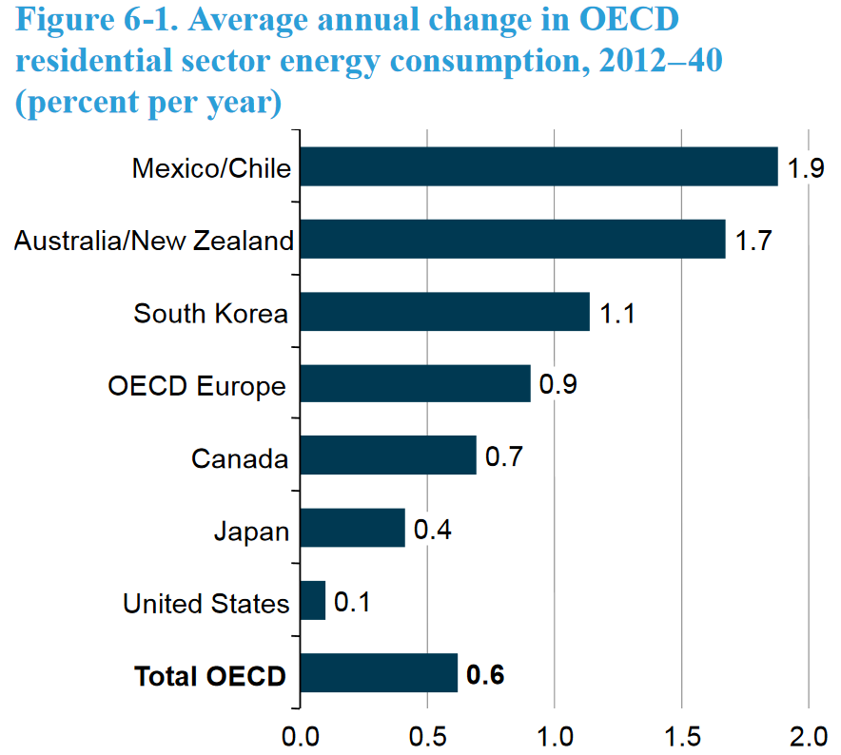

Figure –Projected Average Annual Change in OECD residential sector energy consumption, 2012-40 (% per year)[3]

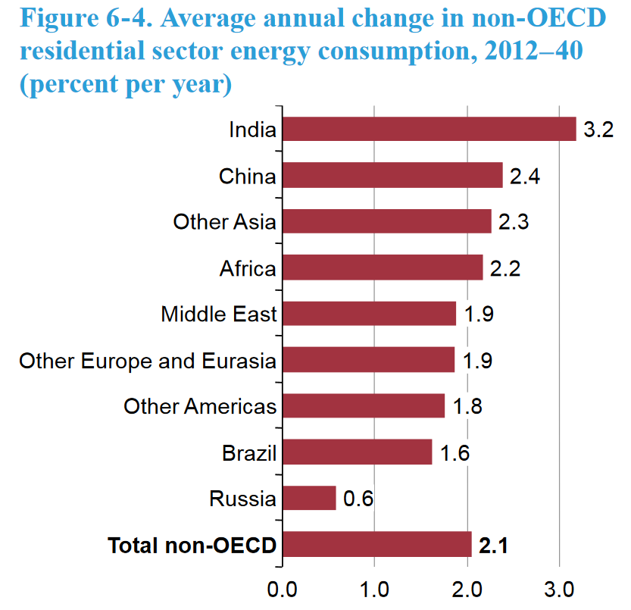

Figure –Projected Average Annual Change in non-OECD residential sector energy consumption, 2012-40 (% per year)[4]

All countries should be pursuing NZB for new construction but even more effort will be required to get existing buildings up to this level of performance. One interesting idea is to require that all buildings meet building codes at the time of major renovations and/or change of ownership. Architecture 2030 has proposed this as a way to achieve the emission reduction targets for countries. In most countries it is rare that even major renovations are required to meet rigorous targets. There is also risk that if major renovations are required projects will be demolished. A better understanding of the life-cycle emissions of buildings is needed to make the best informed decision for such situations.

**NZB Definitions**

There are a number of definitions for NZB which has created some confusion in the building industry. The following are all different definitions of “net zero buildings”[5]:

* Net Zero **Energy (Cost)** – the amount of money the utility pays the building owner for the energy the building exports to the grid is at least equal to the amount the owner pays the utility for the energy services and energy used over the year.
* Net Zero **Energy (site)** – energy production onsite is at least as much as the building uses in a year, when accounted for at the site (this excludes losses from power plants and transmission).
* Net Zero **Energy (source)** – energy production onsite is at least as much as the building uses in a year, when accounted for at the source (taking into account the primary energy used to generate and deliver the energy to the site). To calculate a building’s total source energy, imported and exported energy is multiplied by the appropriate site-to-source conversion multipliers.
* Net Zero **Energy (emissions)** – renewable energy produced on site and exported is at least as much as is used from emissions-producing energy sources.

A number of organizations have defined these with subtle differences but the NREL definitions referenced above cover the core concepts of each. In the United States people have become very focused on net zero energy buildings. The Department of Energy even published a definition of NZE as a focus on that building type.

Discussions around NZB in most the rest of the world involves net zero carbon buildings. In the UK these have been called zero carbon buildings[6], Australia has called them Beyond Zero Emissions[7], Hong Kong has used the term zero carbon buildings (ZCB)[8], Europe has a wide variety of definitions as outlined in the EPBD report ‘Towards nearly zero-energy buildings’[9] which shows just how many definitions of the topic there are.

Some recent definitions of NZB have confused the building industry further including the definitions in the State of California. These include hourly price weighting where buildings have a time dependent schedule that values energy produced during peak electrical times more than other times. This create a weighted net zero cost model that is actually very different than net zero energy or carbon buildings.

In Europe there are a wide range of definitions and adoptions rates of NZB by different countries. The countries have typically set the NZB definition in terms of primary energy (which is the equivalent to the source energy definition above). Beyond the NZB definition some countries have set a number of other requirements including target U-values, maximum transmission losses and minimum efficiency factors for portions of buildings.[10] Europe does have adoption targets for nearly zero energy buildings (nZEB).

**Buildings that can achieve NZB Status**

Most new buildings have the potential to achieve or come close to achieving net zero building performance. The key to achieving this is good design and on-site energy generation. In the past five years there are examples of net zero buildings with almost every building type including offices, banks, retail stores, single family homes, multi-family homes, grocery stores, schools, museums and many more.

Net zero buildings by definition are limited to mid-size buildings as it is challenging for really large (6 stories or taller) or very energy intensive buildings (like hospitals) to generate as much energy as they consume. The ability for a building to achieve NZB status is directly related to its size, energy use intensity and the renewable resources available on the site. When using solar energy alone it is very challenging for buildings (with current PV technologies) to get above 5-8 stories and still achieve NZB. That being said, the majority of buildings are below this height. Even in China which has some of the highest urban occupancy densities the majority of buildings are in the range where NZB are possible. [11]

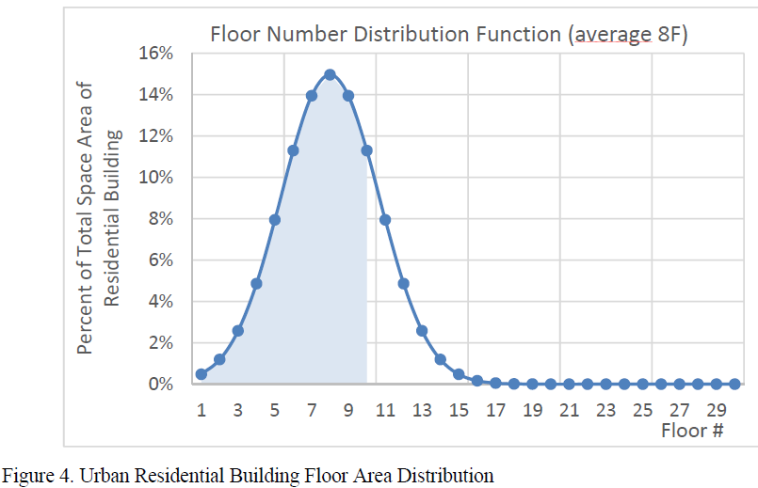

Figure – Urban Residential Building Floor Area Distribution in China

Net zero building performance has recently been adopted by many more building types including retail. One example is the net zero Walgreens in Evanston, Illinois. This project includes many energy efficiency options including daylight harvesting, geothermal wells, LED lighting, CO2 refrigerant for equipment, wind turbines and rooftop solar PV. This Walgreens store helps demonstrate that NZB performance is possible for chain retail stores.

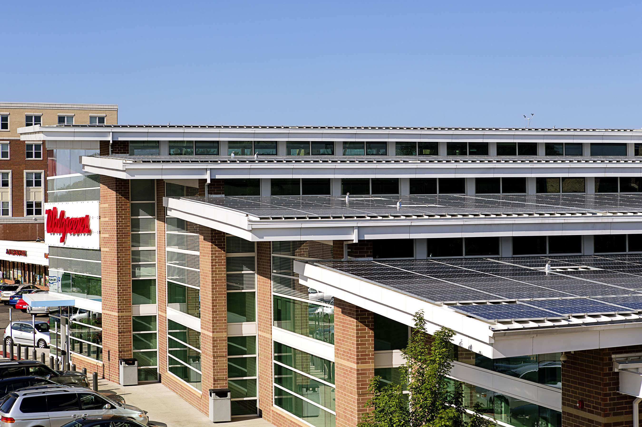

Figure –Net Zero Walgreens[12]

Larger buildings have also been able to achieve NZB status. The Bullitt Center is a great example of a mid-rise office building that has been able to achieve net positive energy performance (generates more energy than it consumes on an annual basis). Located in Seattle, the building has six stories of office space that are fully occupied. Despite having lower solar resources than much of the USA, the building has been outperforming expectations. This is a great example how NZB can be applied to the majority of new building construction in the USA as most buildings are less than six stories tall.

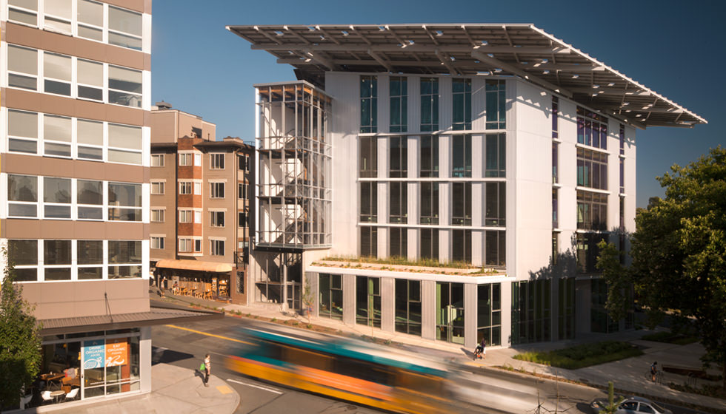

Figure –Bullitt Center[13]

Renovations are harder to achieve NZB status but they are the most critical portion of the building stock that need to be upgraded. There have been a number of recent renovation projects that have demonstrated how deep energy retrofits can achieve close to NZB performance. The Tighthouse project in New York City is a great example. This project took a 120 year old brownstone building and renovated it with high levels of insulation, air tight construction and very efficient HVAC systems. This was able to generate a renovation that was 84% better than code.[14] The project was the first certified Passive House project in New York City.

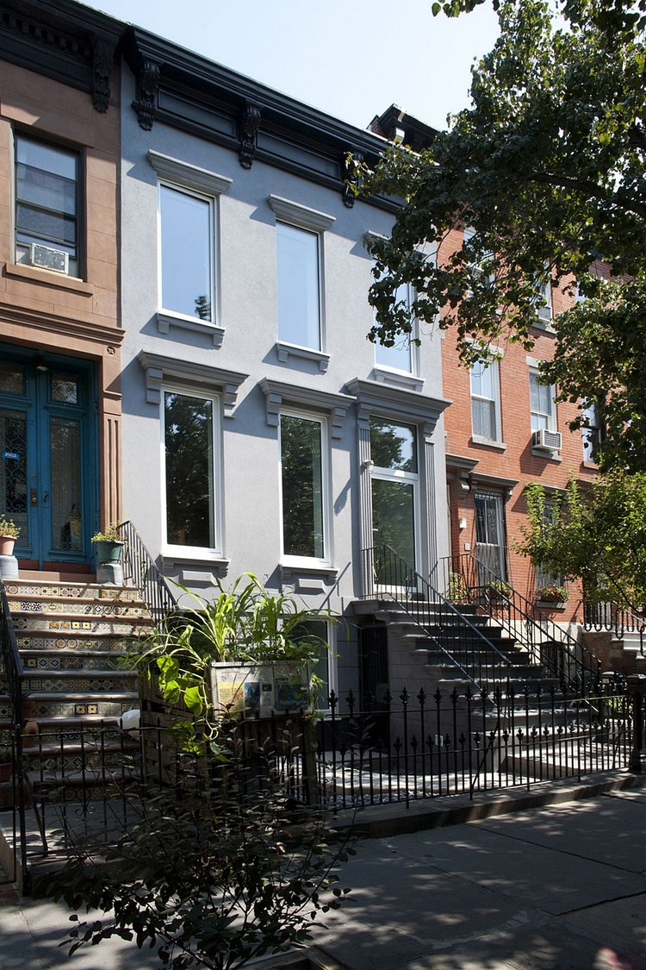 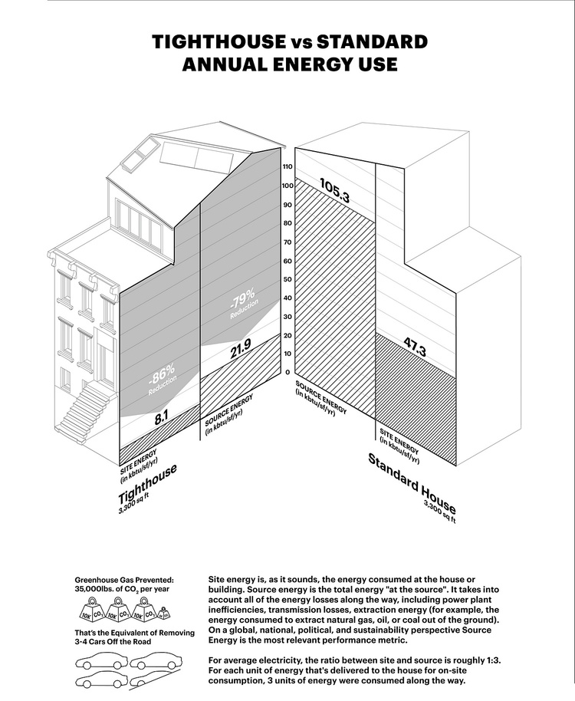

Figure – Tighthouse – Passive House[15]

Another great renovation example is the Rice Fergus Miller Office and Studio project which ranks among the lowest energy use buildings in the US. [16] This project took the 1948-built Sears Automotive Center building that had been vacant for 24 years and turned it into a high performance office building. The building has been performing at 21.2 kBtu/ft2/yr (66.9 kWh/m2/yr), which is 77% better than the Commercial Buildings Energy Consumption Survey (CBECS) 2003 national benchmark for office buildings of 93 kBtu/ft2/yr (293.4 kWh/m2/yr).

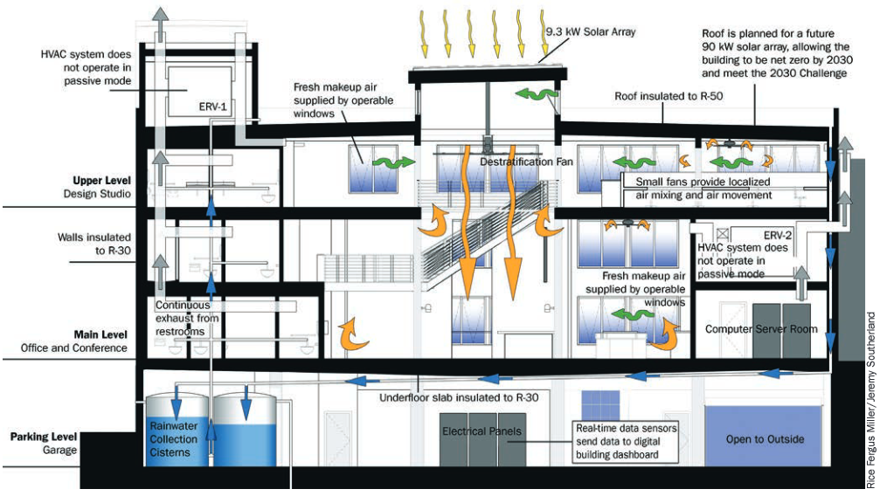

Figure –Rice Fergus Miller Office – Automotive Building Renovation[17]

**Prevalence of NZB Projects**

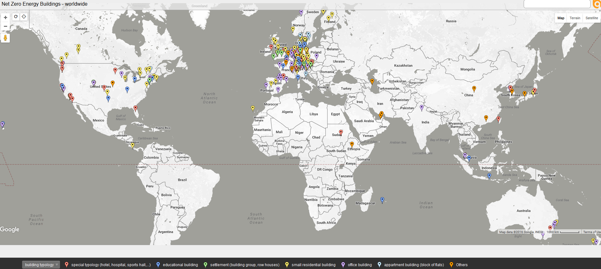

Figure – Map of Net Zero Buildings Worldwide [18]

There are net zero buildings all over the world. The concept has been adopted and adapted to different regions but continues to gain momentum. The map above documents the distribution of net zero buildings based on the IEA research “Towards Net Zero Energy Solar Buildings” and shows distribution up to 2013. This document was focused on the EU and its building programs. The programs in the EU are more regulatory while other portions of the world have had NZB buildings developing through voluntary programs.

The USA & Canada in particular have far more NZB buildings than shown on the map above. There are over 3,000 buildings that have been documented by the Net Zero Coalition in the USA and Canada[19]. The map below shows these buildings. California has the largest percentage of these but there are cases located throughout both countries. The difference in documented buildings and the approach towards achieving NZB reflect cultural differences between North America and Europe. The voluntary approach in North America has created many innovative projects that achieve NZB status but Europe appears to be achieving greater strides forward by mandating change.

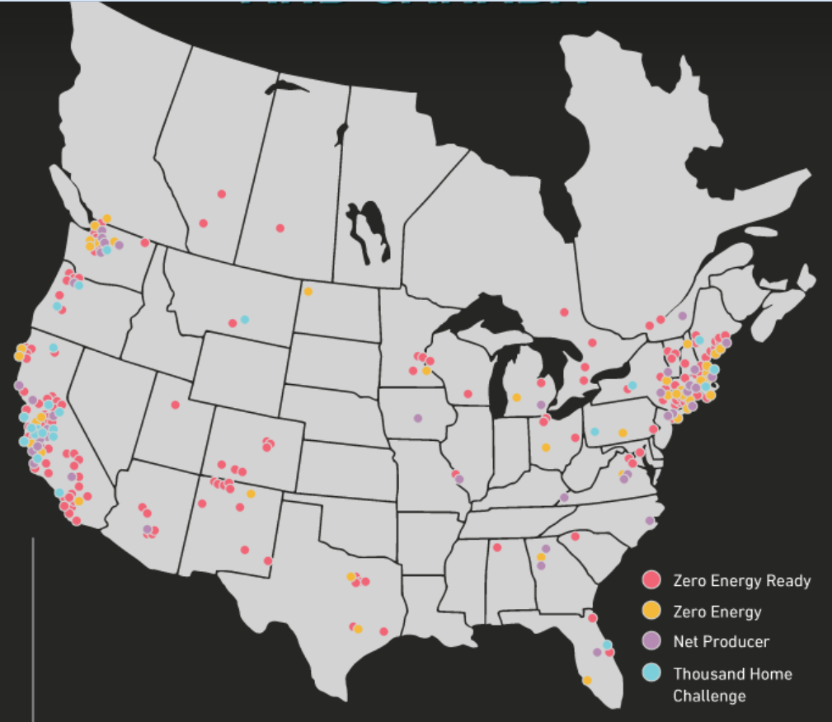

Figure – Map of Net Zero Buildings in the USA & Canada[20]

**United States** – Most NZB projects in the USA are all voluntary with different organizations choosing to meet the goal. There are a number of voluntary NZB programs that have been developed in the USA including the Living Building Challenge, International Living Future Institute (ILFI) Net Zero Certification and the New Building Institute (NBI) database. These voluntary systems provide third party reviews of buildings post occupancy to verify that they are actually performing per the NZB definitions. The USA has energy codes that are specific to each state and California has adopted net zero energy cost as a requirement for projects. All new residential buildings in California will have to be NZB by 2020 and all new commercial buildings by 2030. The California definition of NZB is based on a time dependent variable (TDV) schedule that values renewable energy that is generated at peak times over non peaks. These buildings really shouldn’t be called NZB but have another term as they may only have a portion of their energy generated with renewables depending on how the TDV schedule values solar energy.

**European Union** – The EU has passed the Energy Performance of Buildings Directive (EPBD) 2010 legislation which requires all new buildings to be ‘nearly zero-energy buildings’ nZEB by 2020. This legislation has been adopted differently in all the member states with a wide range of national plans. The definition of nZEB even varies by country. This adds significant confusion to the goal but adoption rates in the EU of nZEB buildings are higher than other portions of the world. In addition the nearly net zero building term adds confusion as they aren’t actually net zero. Similar to California it would be clearer for the public if these were termed something like ultra-low energy buildings. Then save the term net zero buildings for ones that are actually achieving this goal.

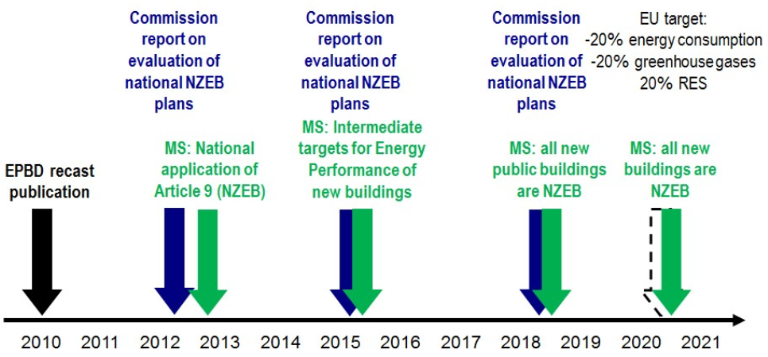

Figure – EU timeline for achieving NZEB[21]

**China**

China represents the largest growth in building area as it is expected to go from 55 billion square meters of floor area in 2010 to 86 billion in 2050.[22] This represents 36% of the total projected global growth in building area. China has the greatest potential to have an impact on buildings now as they are building so quickly. Despite this net zero buildings and nearly zero building principles have not been widely adopted in China to date. China has recently established a long term energy efficiency improvement plan where net zero buildings are one of the main goals. [23]

## Adoption Path

Adoption methods for NZB vary significantly throughout the world. Only relatively recently was a coalition formed to set global targets for NZB performance. In the summer of 2016 countries from around the world agreed to net zero building performance when “…Green Building Councils from Australia, Brazil, Canada, Germany, India, Netherlands, South Africa, and Sweden” decided to initially take part in the project[24].

Long-term targets include:

* All new buildings and major renovations should be net zero starting in 2030, meaning no buildings should be built below net zero standards beyond 2030. 100% of buildings should be net zero by 2050,
* 75,000 professionals trained on net zero building by 2030, and 300,000 by 2050,
* All Green Building Councils which operate certification schemes, having a net zero tool in place by 2030.

This represents a great leap forward as countries start to agree on what NZB is and how to achieve it. Architecture 2030 has been leading this discussion for the past decade when Ed Mazria first set the 2030 Challenge for buildings. The 2030 Challenge sets multiple reduction strategies for buildings with the goal to achieve net zero emissions by 2030 for all new construction.

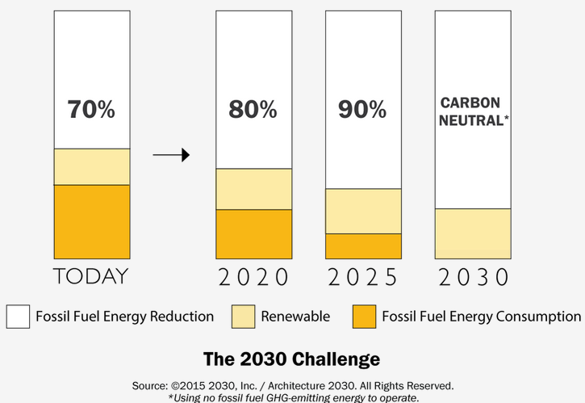

Figure – The 2030 Challenge Energy Reduction Targets [25]

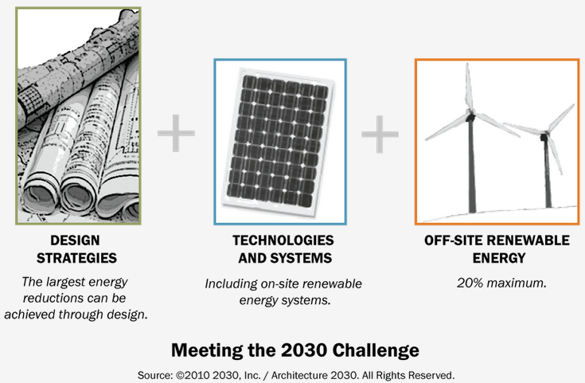

Figure – Meeting the 2030 Challenge[26]

**AIA 2030 Commitment**

Though the 2030 challenge has been around for a decade the adoption rate has not been as high as hoped. The American Institute of Architects setup the 2030 commitment which has been adopted by over 140 architectural firms and tracks the performance of projects around the world. The 2014 report had project submissions from 51 countries around the world.[27] 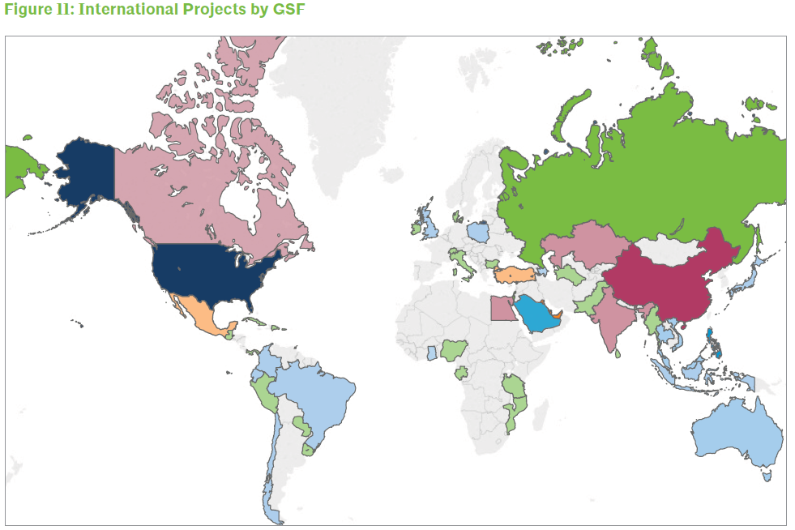 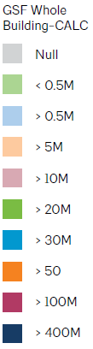

Figure – AIA 2030 Commitment – Global Projects by gross square feet [28]

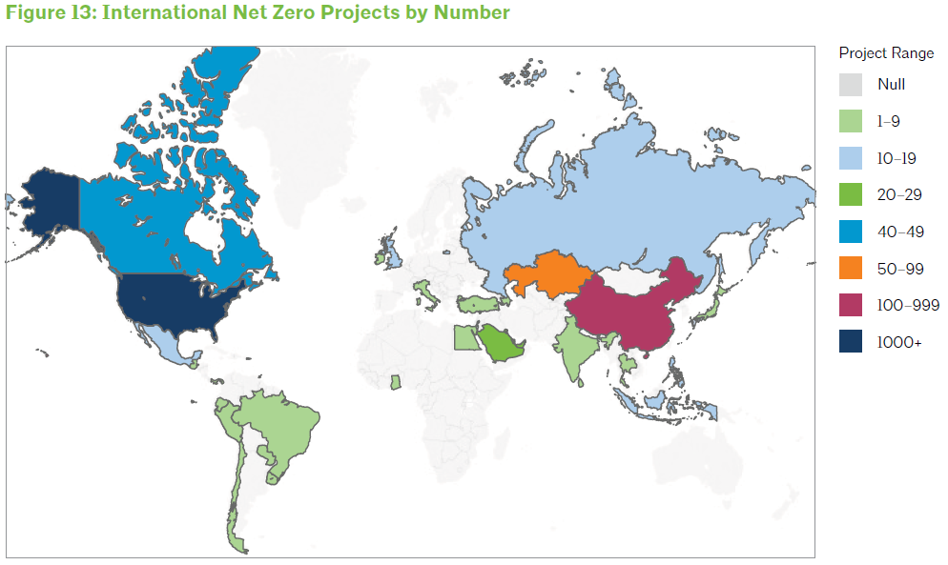

Figure – AIA 2030 Challenge – Record of International Net Zero Projects [29]

Though many firms have made the commitment not many projects are actually achieving the performance reductions set by the challenge. Between 2010 and 2014 only an average of 11% of projects were achieving the 60% energy reduction target set by the challenge.

Figure – AIA 2030 Challenge – Percentage of Projects Meeting the 60% Energy Reduction Target[30]

Though 60% energy reductions have been challenging to achieve projects have been achieving energy reductions of 21-47% on average based on project use type. The chart below shows typical building types and their relative performance.

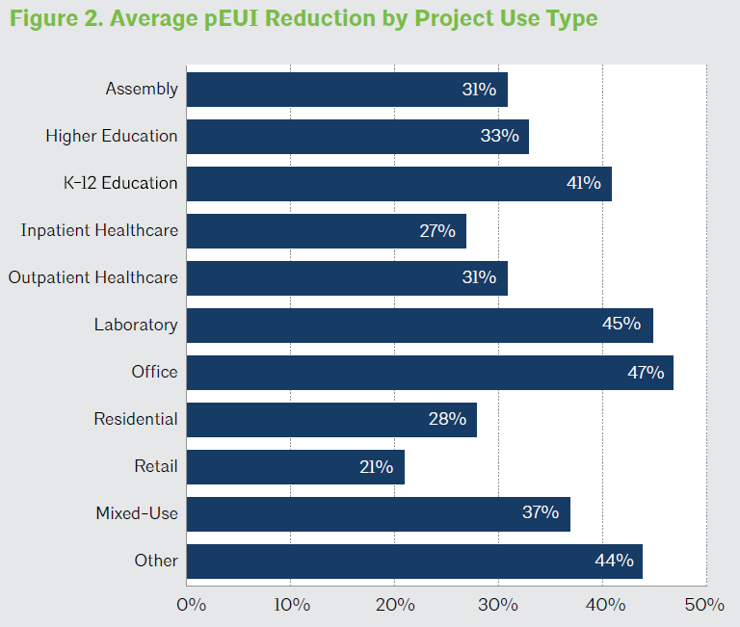

Figure – AIA 2030 Challenge – Average pEUI Reduction by Project Use Type [31]

Despite the progress made in the past decade much greater energy efficiency reductions are needed for projects to start being on track to hit the targets set out by the 2030 challenge. Current average energy efficiency reductions are typically not enough to offset the impacts of adding new building square footage and the GHG emissions associated with their operation.

**Building Envelope**

One key technology that is different in net zero buildings compared to other Drawdown solutions is the building envelope. Building envelopes have the opportunity to facilitate or hinder excellent energy performance. The key to improve performance is with climate specific façade solutions that respond well to the annual climatic conditions. For instance, in colder climates buildings can have high levels of insulation which creates an inexpensive method to store heat effectively. The envelope can be thought of a thermal battery. The better it performs the more likely it is to keep heat in or out when required.

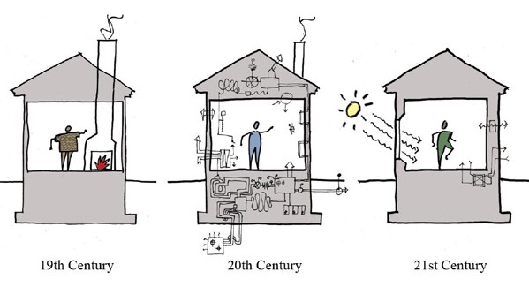

Figure – In contrast to hybrid cars, Passive Houses arguably are a step back to greater simplicity. Via Albert, Righter & Tittmann Architects[32]

Renovating building envelopes has enormous energy saving potentials especially in countries where significant heating load exists. The renovation of existing buildings has some of the greatest CO2 saving potential.[33] Building codes, designers and builders should focus on reducing heating and cooling loads in existing buildings.

## Implementing Net Zero Buildings

The majority of new buildings today could be net zero. Why isn’t this happening? What are the major hurdles? The main item usually sited is cost. There is a premium for these buildings and people often think it is so high that it is not worth pursuing. Another key issue is that developers and builders don’t have much of any incentive to build NZB projects. The real estate market has not been pricing the features that facilitate NZB status such that the market is demanding it. In addition to this, developers who sell buildings don’t reap enough financial benefits from investing in energy efficiency or on-site energy production.

The real estate industry needs economic drivers that create the proper value for NZB features. This is an issue throughout the economics of the real estate industry. Building appraisers don’t typically know how to appraise NZB features. Real estate listings don’t feature performance as a value item. On-site energy production is not properly valued at the time of resale. All of this is a failure of the current economic system to value building performance.

European countries have been implementing Energy Performance Certificates (EPC) for buildings for years. These are shared during real estate transactions so buyers know the performance of a building before purchasing it. This creates better transparency in the marketplace and creates economic incentives for building owners to improve the performance of their buildings.

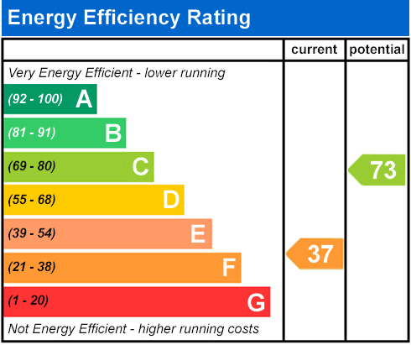

Figure – Example of an Energy Performance Certificate in the UK

There has been a trend of increasing NZB projects every year. This appears to be driven by increased awareness and publicity for NZB performance. It has also been supported by greatly reduced costs for LED lighting and photovoltaic (PV) panels. These two technologies have dropped in cost dramatically in the last five years making it far more economically viable for projects to achieve NZB status. PV in particular has become competitive with many efficiency options that used to be much more affordable. It is more common to have a relatively efficient building with the maximum capacity of PV (rather than a super-efficient building with some PV).

## Advantages and disadvantages of Net Zero Buildings

Net zero building incorporate many different technologies to achieve their performance goal. There really isn’t any one technology that leads to NZB performance but rather a combination of technologies that make up an excellent sustainable design. It is key these technologies are balanced in their implementation so a cost effective NZB performance can be achieved.

NZB or nearly NZB should be adopted as a goal for all buildings. The majority of buildings being built today have the potential to achieve or come close to achieving net zero performance. An example of this can be seen in the chart below which shows the distribution of total floor area included in the 2012 CBECS (Commercial Buildings Energy Consumption Survey) data. This data is meant to show typical performance of commercial buildings across the USA. Note how the majority of buildings included (78%) are three floors or less in height. With current building technologies almost all of these buildings should be able to achieve or come close to achieving NZB performance.

Figure – 2012 CBECS – Percent of Surveyed Building Area at Different Stories[34]

In addition to having the right technologies, NZB performance requires that people operate buildings well. Buildings are even more sensitive to human behavior than a car which reacts to a driver’s behavior to influence the miles per gallon achieved. If people leave devices running all the time, take long showers, leave lights on longer than needed, and so on the performance of a building can go down significantly. A good example of post occupancy performance can be found in the Net Zero Affordable Housing Community of Kaupuni Village. Located in Hawaii, the development includes 19 single-family homes and a community resource center.

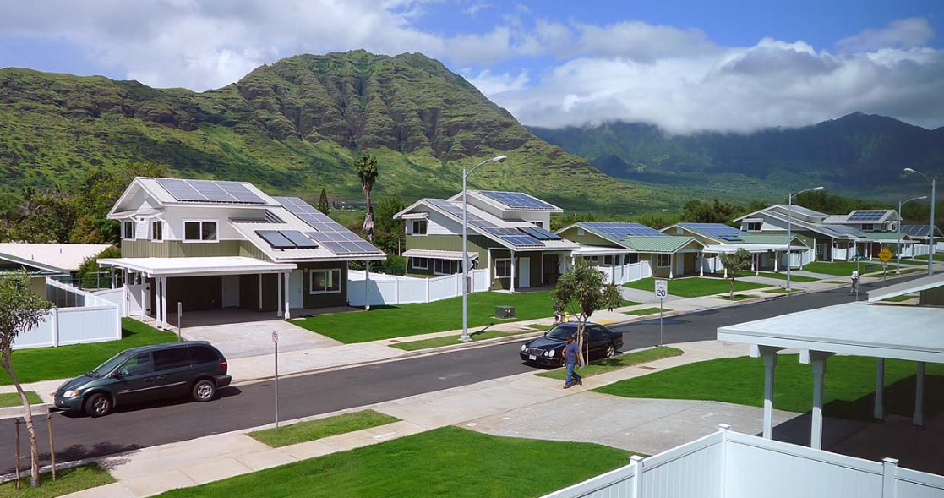

Figure – Kaupuni Village – Net Zero Energy Affordable Housing Community in Hawaii[35]

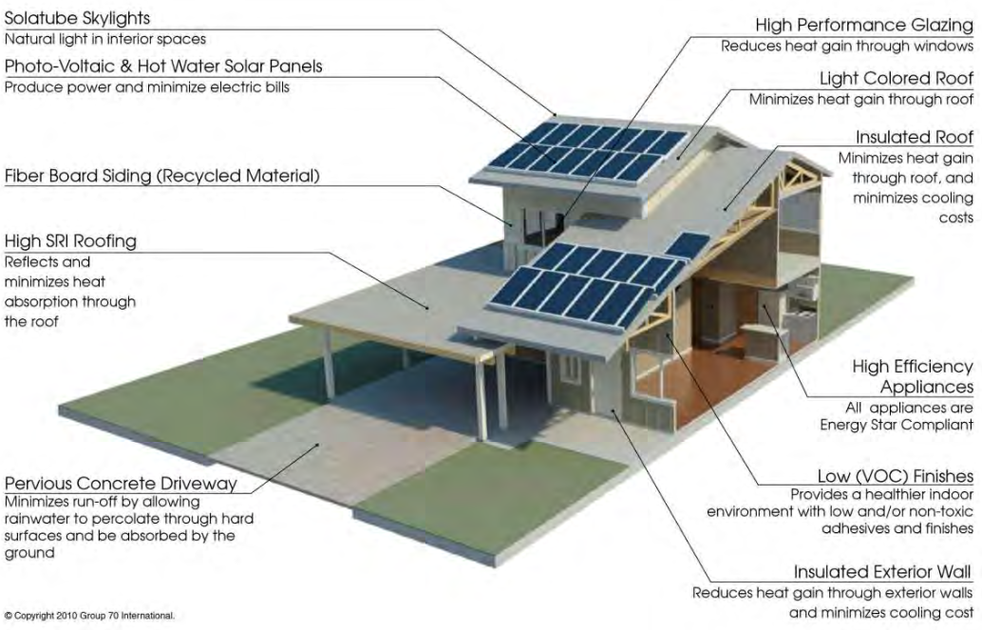

Figure – Kaupuni Village – Net Zero Energy Affordable Housing Community in Hawaii[36]

The chart below shows how the different homes in Kaupuni Village performed relative to their PV output. Note how there are net energy producers and consumers in the mix. Many homes operated close to the NZB threshold but many used more or less energy. This is an excellent example of how much human behavior impacts NZB performance. Note, how two of the buildings used almost twice as much energy as they produced while one home produced almost twice as much as it used. These variations are bound to happen based on human usage patterns but the hope is that with better information and a clear goal, people are more likely to use energy in ways to achieve the NZB goal.

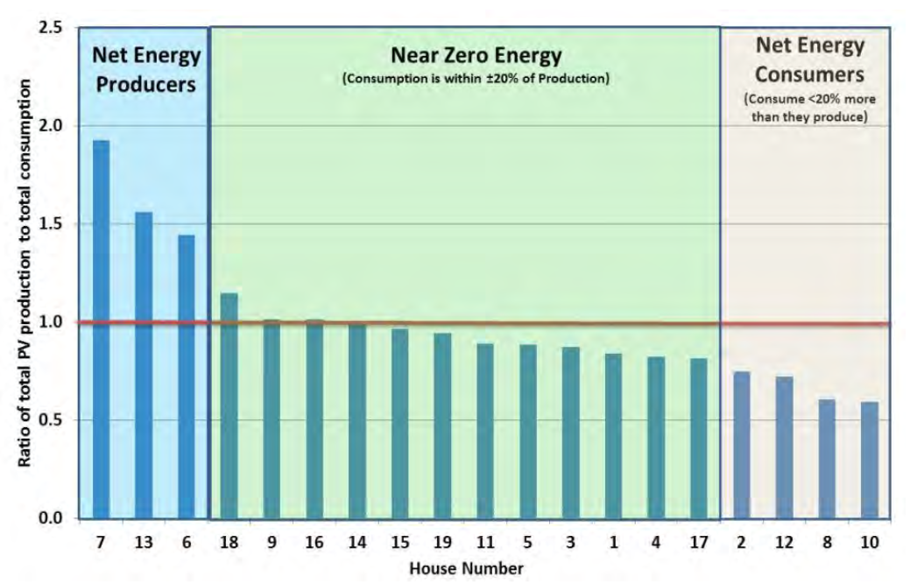

Figure – Kaupuni Village – Net Zero Post Occupancy Performance of Homes [37]

**Perception of Cost Hurdles**

Net Zero homes are starting to become more mainstream as some builders have started to advertise and build these in new developments. One example is Meritage Homes which has constructed over 100 net zero homes. Meritage has stated that they can achieve net-zero status for homes that cost as little as $200,000.[38] Meritage has also stated that the technology is financially solved but it is a matter of the consumer catching up to the concept.

Other builders disagree with this as they haven’t seen demand for net zero homes. Toll Brothers Inc., Lennar Corp. and D.R. Horton Inc. all prefer to offer energy efficient homes but aren’t seeing demand for net zero homes.[39]

* 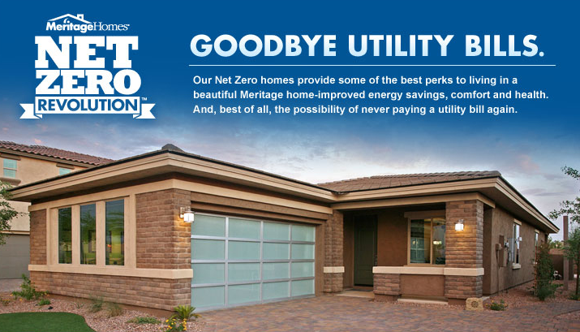

Figure – Meritage Homes – Net Zero Revolution Ad [40]

## Net Zero Building Archetype

Net Zero buildings do have trends in the adoption of certain technologies. The technologies will be very dependent upon the climate in which a building is located but the following are key elements for NZB projects.

**LED Lighting & Daylight Controls**

*Please reference the LED lighting Drawdown solution.* Both LED lighting and daylighting controls are key technologies for NZB projects. LED lighting offers significant energy savings over older technologies while daylighting is the most efficient form of light for buildings. Automated daylighting controls combined with LED have the potential to dramatically reduce the energy needed to light a building.

**Passive Design Concepts**

*Please reference the Passive House Drawdown solution.* Almost all NZB projects implement some level of passive design in the building form and details. These features are highly dependent upon the climate zone the building is in but can include proper orientation, passive solar shading, natural ventilation, passive daylighting, night flush cooling, earth tubes, wind responsive design and tuned thermal mass.

**Excellent Solar Control**

*Please reference the Glazing for Buildings Drawdown solution.* NZB projects need to respond to annual solar gains to optimized performance on each façade. This is very dependent on climate but can include passive and active solar shading technologies. Passive technologies include the percent of a façade that is glazed, glass solar heat gain coefficients, glass U-values, external solar shading, advanced microshades, integrated laminate materials and adaptive landscaping as shading. Active solar technologies include external operable shades, electrochromic glass, thermochromic glass and internal operable shades.

**Super Insulated Envelope**

*Please reference the Passive House Drawdown solution.* Building envelopes should be insulated well beyond current building codes but the level of insulation is dependent on the climate. This is a key technology as the building envelope acts as a thermal battery. The better the insulation the better the heat is kept in and the less heat is needed to be added. This technology is key as can offset the need for fossil fuels when the sun does not have as much output. The winter months can then have reduced energy usage through super insulation when the solar output of PV is the lowest and the need for fossil fuels tends to be highest.

**Airtight Envelope**

*Please reference the Passive House Drawdown solution.* Building envelopes lose heat both through conduction and air infiltration. Airtight envelope construction is needed in addition to super insulation as the air leaks can have significant impacts on building performance. Airtight construction standards have become more common thanks to movements like Passive House which have helped make the standards, testing and implementation more mainstream.

**Solar Roof**

*Please reference the Solar PV Drawdown solution.* Almost all NZB projects include rooftop solar. Other renewable technologies are typically hard to implement on most project sites. Wind for instance rarely works well for buildings as very windy sites are needed along with tall wind turbines. Solar on the other hand is universally available and even sites in more Northern latitudes can still achieve NZB performance.

**Localized Conditioning**

*Please reference the HVAC Efficiencies and Building Automation Systems Drawdown solution.* One key concept in NZB performance is conditioning spaces only as much as needed to achieve occupant comfort. This means buildings are not over conditioning spaces when unoccupied and the HVAC systems are designed to achieve comfort at the occupied level. Spaces outside this zone can then be allowed to float higher or lower depending on the design conditions.

**Dedicated Outside Air System (DOAS)**

*Please reference the HVAC Efficiencies Drawdown solution.* DOAS systems are key to NZB performance as they separate the ventilation system from the heating and cooling. This allows buildings to have excellent indoor air quality while avoiding having to condition excessive amounts of outside air.

**Heat Pump Technology for Heating, Cooling and Domestic Hot Water**

*Please reference the HVAC Efficiencies Drawdown solution.* Most NZB projects make use of heat pump technologies in some portion of the building. Heat pumps are especially effective for heating as they offer a coefficient of performance that makes them 2-5 times as efficient as fossil fuel systems like natural gas boilers.

**Avoiding Variable Refrigerant Flow (VRF) Technologies**

*Please reference the HVAC Efficiencies Drawdown solution.* VRF systems have been adopted widely to help achieve energy savings but NZB projects should avoid this technology due to the high volumes of refrigerant that the technology uses. VRF pumps refrigerant around buildings to achieve heating and cooling. The refrigerants used have a high global warming potential and are very prone to leaks. In addition to this much of the refrigerants in the world are not recycled and are just released into the atmosphere at their end of life. The energy savings of VRF can be completely offset by the leaks of the refrigerants used in the systems.

# Methodology

## INTRODUCTION

In order to analyze the impacts of net zero (and nearly zero) buildings both now and in the future the multiple area projections and adoption scenarios were analyzed. These include the Architecture 2030 framework, LEED Platinum building adoptions as a proxy for NZB, AIA 2030 actual adoption data and growth rates for NZB projects. The calculation methodology does vary from other Drawdown solutions as it is a way to test the bounds of impacts on NZB for new construction. The solution is note being counted the same as other solutions as NZB projects will have multiple Drawdown solutions in them and there is no way to avoid double counting.

Architecture 2030 has set energy reduction targets that step up every five years. Today it is 70% better than a CBECS building use baseline and it ramps up 10% in 2020 and 2025 until hitting net zero in 2030. These goals have been adopted by a wide range of organizations and countries. This framework was part of the focus at the Buildings Day for the COP21 in Paris.[41] As part of the Paris agreement the World Green Building Council (GBC) is working to ensure the 74 regional green building councils to commit to reduce CO2 emissions from the building sector by 84 gigatons by 2050.[42] The plan is to achieve this through net zero buildings and building energy renovations. Here are the specifics of the 2030 challenge:

*At a minimum, an equal amount of existing building area shall be renovated annually to meet a fossil fuel, GHG-emitting, energy consumption performance standard of 50% of the regional (or country) average for that building type.*

*The fossil fuel reduction standard for all new buildings shall be increased to:*

* *70% in 2015*
* *80% in 2020*
* *90% in 2025*
* *Carbon-neutral in 2030 (using no fossil fuel GHG emitting energy to operate)*

*These targets may be accomplished by implementing innovative sustainable design strategies, generating on-site renewable power and/or purchasing (20% maximum) renewable energy and/or certified renewable energy credits.[43]*

The Drawdown analysis uses this framework for new buildings. This creates the ability to see both the effects of net zero buildings and nearly zero buildings that have undergone significant energy conservation measures but don’t have on-site energy generation. These buildings are sometimes referred to as net zero ready buildings as all they need is rooftop PV to offset their energy use. Some building owners are opting for this and waiting for additional financing to become available for PV or hoping that the costs of PV will drop further.

## DATA SOURCES

The current energy usage by buildings globally was collected from both the EIA and IEA. Both data sets were very close in energy usage and projected usage growth by the building sector. These data sources established the total addressable market for net zero buildings. The energy usage and emissions projections were compared to the ETP 2016. The total addressable market and the implementation unit were set as square meters as it is the best metric to bridge between energy use and energy cost in buildings. The current global building square footage is a number that is more inconsistent based on different sources. The figure below shows the estimated building area numbers by the Global Building Performance Network (GBPN)[44], Navigant[45] and McKinsey[46]. Note the significant variation between the sources.

Figure – Global Building Area Projects by Source

When looking at the projected growth rates the Navigant data best aligned with the information from the EIA and IEA. This is because the growth rate of energy consumption in the building sector aligns much better compared to the GBPN or McKinsey data.

The Navigant data assumes a growth rate of 1.4% for commercial buildings and 1.2% for residential buildings. [47] This rate was applied to both building sets annually for a projected growth rate. The building area data projections were then combined with the global energy projections to get a typical energy use per unit area.

## ADOPTION SCENARIOS

Multiple adoption scenarios were modeled to look at the potential impacts of net zero buildings.

### BUSINESS-AS-USUAL

The business as usual scenario is straight from the EIA and IEA energy projections for buildings. These are shown below for energy use from 2010 to 2050 for the building sector. This chart takes the 2013 building emissions globally per unit area and projects it out following the projected building area growth rate. Note how it also has the ETP 2016 6 degree scenario projection for building emissions. The building as usual projection (assuming current emissions rates times the building growth rate) is much worse than even the 6 degree ETP scenario.

*Figure 25 –* *Business as Usual Emissions Growth compared to the ETP 2016 6 degree scenario.*

### OPTIMISTICALLY PLAUSIBLE

Projections for energy reductions used the ideal scenario for the architecture 2030 policy globally, a more conservative change based on performance data from the AIA 2030 commitment, projected NZB growth rates from current NZB projects and LEED Platinum growth rates applied to NZB.

The ideal solution assumes all new construction meets the energy reduction thresholds set by the 2030 challenge for new construction. This is 70% below the baseline today ramping up 10% each five years till all new construction is net zero in 2030. Major renovations are assumed to all be 50% below the baseline starting now and staying at that level for the rest of the time period. Renovations are excluded from the NZB projections.

The more plausible solution based on recent performance data looks at the actual adoption rates of projects that are part of the AIA 2030 commitment. Though architecture and engineering firms have made the commitment, not many projects are actually achieving the performance reductions set by the challenge. Between 2010 and 2014 only an average of 11% of projects were achieving the 60% energy reduction target set by the challenge.

*Figure 26 –* *AIA 2030 Challenge – Cumulative Area of Projects Meeting the Architecture 2030 60% Energy Reduction Target*

Figure – AIA 2030 Challenge – Percentage of Projects Meeting the Architecture 2030 60% Energy Reduction Target[48]

The projection thus uses this same average adoption rate noting 11% of buildings reaching the 2030 targets for the life of the program. This means 11% of new construction would achieve net zero energy each year from 2030 on.

LEED Platinum growth rates were used as a proxy to see how this growth rate would impact NZB projects. The growth rate of LEED platinum projects is shown in the chart below. Based on the historic growth rate a continued growth rate of 25% was used to project the growth of this type of buildings.

*Figure 28 – Cumulative LEED Platinum Building Area*

A similar methodology was used for NZB which looked at the current NBI global database of NZB projects and applied a growth factor based on their data. The growth rate of NZB was assumed to be higher initially and then taper off over the next 34 years. The cumulative NZB area projections are shown below.

*Figure 29 – NZB Projected Building Area*

## CLIMATE AND FINANICAL IMPACTS

The climate reductions assume the building stock will have the energy reduction factors noted in the sections above and then achieve emissions reductions in tandem.

CLIMATE INPUTS

* The direct emissions factor uses 118,234 mtCO2e/TWh which takes the total emissions for the building sector documented by the IEA and divides it by the total TWh for buildings.

### FINANCIAL INPUTS

Cost data is challenging to compare as the premium for a net zero building is relative to different baselines which are set based on societal building standards. For instance, homes may not need expensive finishes and materials but society may build these into the ‘baseline’ price. Costs can vary significantly due to the different assumptions of what a building needs. Some of the best cost data for net zero comes from the EU where they have documented the premium for nearly zero energy buildings across the union. The table below is from a detailed report outlining the costs of these buildings compared to the current national minimum energy performance requirements.

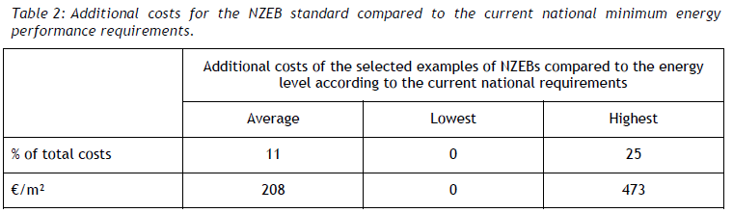

*Figure 30 – Additional costs for nZEB buildings in the EU[49]*

The average was found to be 11% which was the largest data set found for the cost premiums for these sorts of buildings. There were cost ranges as seen in the chart below with some buildings essentially seeing no cost premium.

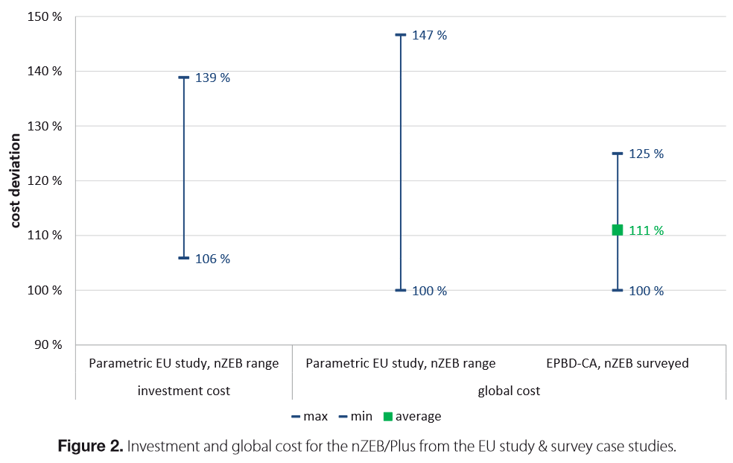

Figure – Cost Deviation of nZEB buildings in the EU[50]

The variations in cost premiums is identified in the chart below which shows premiums for the quality of construction and different building components. Note how the envelope and HVAC systems only have small premiums over standard buildings.

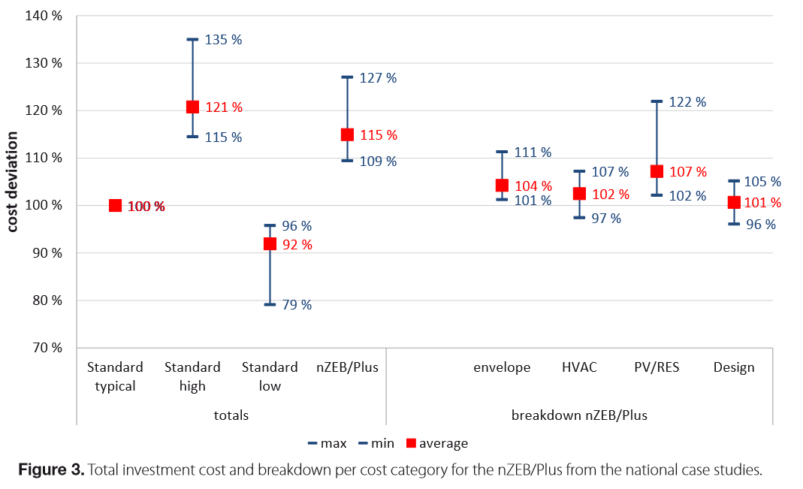

Figure – Cost Deviation by technology and quality of construction for nZEB buildings in the EU[51]

Though the premium for net zero buildings is not insignificant, it is small enough that more projects could definitely achieve this level of performance. As the cost of PV and LED drops this will help reduce the cost premiums. The other key will be for heat pump technologies to reduce in price so more buildings can take advantage of the efficiency of this technology for heating.

## ASSUMPTIONS

The following assumptions were made for the net zero buildings solution.

* The ideal solution includes the architecture 2030 framework for tiered reductions in energy use and all new buildings achieving net zero by 2030 was assumed to be adopted globally. Building renovations have been excluded.
* This is supported by recent policy decisions stemming from the Paris agreement.
* The AIA 2030 commitment has realistic adoption rates for projects.
* Despite the great goals of policies like the 2030 challenge actual adoption rates have been lower than the goals. The AIA 2030 data set shows a conservative adoption rate based on society’s recent behavior.
* LEED Platinum growth rates were used as a proxy to estimate the potential growth rates of NZB projects.
* NZB growth rates were estimated from the NBI database.
* Cost premiums for net zero buildings are around 11% per research from the EU.
* The EU dataset is the best found for cost premiums. Cost data is challenging to find for this type of construction as it is highly dependent on the building use, size, quality of construction and number of modern system requirements.

## LIMITATIONS / FURTHER DEVELOPMENT

The solution makes use of the best data found on net zero buildings. There is limited information on portions of this solution including the cost premium and the performance of buildings in many developing countries. The model would be more robust if it had regional nuances highlighting the performance of developed and developing countries in detail.

# Results

The chart below shows the potential NZB adoption scenarios. Note the ideal architecture 2030 chart versus the rest. Currently NZB buildings make up a very small fraction of the build sector. Only with very high growth rates will NZB be able to start to come close to the AIA 2030 average adoption growth rate. This shows how far the ideal scenario is from the current reality. Though the number of NZB projects are growing globally they are not growing at anywhere close to the rate of the targets set forth by architecture 2030.

Figure – Global Adoption Scenarios (as square meters) for Net Zero Buildings

The data is complicated by multiple building area projection factors. Predicting the amount of new building area added globally is very challenging and different data sources can have varying projections. Note in the chart below the difference in the projections between the Navigant and GBPN TAM data. The Navigant TAM assumes a slower growth rate in buildings thus the NZB scenarios have a lower adoption percentage as compared to the GBPN data.

The chart below shows the projected emissions from all of the options including the business as usual projections from the EIA, the ideal 2030 net zero adoption rate, LEED and NZB proxies and the AIA 2030 adoption rate.

Figure – Global Emissions Projections for Net Zero Buildings

The chart below shows the relative GHG savings from each of the adoption scenarios. Note how the ideal architecture 2030 path is much higher than the other options.

Figure – Global Emissions Savings from Net Zero Building Adoption Scenarios (Million Metric Tons of CO2e)

# Discussion

The solution makes use of the best data found on net zero buildings. The projections of performance are based on a number of factors that could change significantly based on the decisions made by society. If energy efficiency and production along with the price of polluting greenhouse gases were properly priced the adoption rate of net zero buildings would be much higher. It is plausible that most new buildings could achieve net zero status now if society priced the driving factors around them properly.

Based on current adoption rates it is unclear how much of an impact NZB will be able to have in reducing the overall building emissions. The architecture 2030 target is where society should be trying to reach but only a very small fraction of buildings are getting close to these goals. Significant improvements in the building sector need to be implemented to see performance increase. Recently the building sector has become more focused on items like occupant productivity, building resilience and equity. Though these are all important items GHG emissions will negatively impact all of them. The building sector should prioritize GHG emission reductions first and implement the rest of the goals outlined above after the emissions start achieving better performance across the sector.

# References

1. Laski, Jonathan. *World GBC Launches Groundbreaking Project to Ensure All Buildings Are “Net Zero” by 2050*. 2016. <http://www.worldgbc.org/activities/news/global-news/worldgbc-launches-groundbreaking-project-ensure-all-buildings-are-net-zero-2050/>
2. Feng, Khanna, Fridley, Ke, Huang, Zhou. *Impact Analysis of Developing Net Zero Energy Buildings in China.* [*http://aceee.org/files/proceedings/2016/data/papers/10_1135.pdf*](http://aceee.org/files/proceedings/2016/data/papers/10_1135.pdf)
3. EIA – Building Sector Energy Consumption. <http://www.eia.gov/forecasts/ieo/pdf/buildings.pdf>
4. EIA – Building Sector Energy Consumption. <http://www.eia.gov/forecasts/ieo/pdf/buildings.pdf>
5. Torcellini, Pless, Deru. *Zero Energy Buildings: A Critical Look at the Definition.* 2006. <http://www.nrel.gov/docs/fy06osti/39833.pdf>
6. King, Clare. *Zero Carbon Task Group Report. The Definition of Zero Carbon.* 2008. <http://www.ukgbc.org/campaigns-and-policy/task-groups/definition-zero-carbon>
7. *Zero Carbon Australia – Buildings Plan.* 2013. <http://bze.org.au/buildings-plan/>
8. *What is a Zero Carbon Building?* 2016. <http://www.cic.hk/eng/main/zcb/>
9. <https://ec.europa.eu/energy/sites/ener/files/documents/nzeb_full_report.pdf>
10. Erhorn & Ernhorn-Kluttig. *Towards 2020 – Nearly Zero-Energy Buildings.* 2015. <http://www.epbd-ca.eu/outcomes/2011-2015/CA3-CT-2015-5-Towards-2020-NZEB-web.pdf>
11. Feng, Khanna, Fridley, Ke, Huang, Zhou. *Impact Analysis of Developing Net Zero Energy Buildings in China.* [*http://aceee.org/files/proceedings/2016/data/papers/10_1135.pdf*](http://aceee.org/files/proceedings/2016/data/papers/10_1135.pdf)
12. Building Design + Construction. Nation’s first zero energy retail store features metal roof, composite panels. <https://www.bdcnetwork.com/nations-first-zero-energy-retail-store-features-metal-roof-composite-panels>
13. *Bullitt Center Photo*. http://www.bullittcenter.org/wp-content/themes/bullittcenter/img/home/Bullitt-026.jpg
14. Zero Energy Design. *Tighthouse Passive House*. http://zeroenergy.com/brooklyn-passive-house
15. Zero Energy Design. *Tighthouse Passive House*. <http://zeroenergy.com/brooklyn-passive-house>
16. Oram, Shawn. Cejudo, Carmen. *Designing for Off.* <http://www.hpbmagazine.org/attachments/article/11872/13Su-Rice-Fergus-Miller-Office-and-Studio-Bremerton-WA.pdf>
17. Oram, Shawn. Cejudo, Carmen. *Designing for Off.* <http://www.hpbmagazine.org/attachments/article/11872/13Su-Rice-Fergus-Miller-Office-and-Studio-Bremerton-WA.pdf>
18. ENOB. *Net-Zero Energy Buildings. Map of International Projects.* <http://www.enob.info/en/net-zero-energy-buildings/nullenergie-projekte-weltweit/>
19. To Zero and Beyond. <http://netzeroenergycoalition.com/inventory-infographic/>
20. To Zero and Beyond. <http://netzeroenergycoalition.com/inventory-infographic/>
21. Erhorn & Ernhorn-Kluttig. *Towards 2020 – Nearly Zero-Energy Buildings.* 2015. <http://www.epbd-ca.eu/outcomes/2011-2015/CA3-CT-2015-5-Towards-2020-NZEB-web.pdf>
22. Feng, Khanna, Fridley, Ke, Huang, Zhou. *Impact Analysis of Developing Net Zero Energy Buildings in China.* [*http://aceee.org/files/proceedings/2016/data/papers/10_1135.pdf*](http://aceee.org/files/proceedings/2016/data/papers/10_1135.pdf)
23. Feng, Khanna, Fridley, Ke, Huang, Zhou. *Impact Analysis of Developing Net Zero Energy Buildings in China.* [*http://aceee.org/files/proceedings/2016/data/papers/10_1135.pdf*](http://aceee.org/files/proceedings/2016/data/papers/10_1135.pdf)
24. Laski, Jonathan. *World GBC Launches Groundbreaking Project to Ensure All Buildings Are “Net Zero” by 2050*. 2016. <http://www.worldgbc.org/activities/news/global-news/worldgbc-launches-groundbreaking-project-ensure-all-buildings-are-net-zero-2050/>
25. The 2030 Challenge. <http://architecture2030.org/2030_challenges/2030-challenge/>
26. The 2030 Challenge. <http://architecture2030.org/2030_challenges/2030-challenge/>
27. Appelbaum, Alec. *The AIA 2030 Commitment. 2014 Progress Report.*  2015. <http://www.aia.org/aiaucmp/groups/aia/documents/pdf/aiab107447.pdf>
28. Appelbaum, Alec. *The AIA 2030 Commitment. 2014 Progress Report.*  2015. <http://www.aia.org/aiaucmp/groups/aia/documents/pdf/aiab107447.pdf>
29. Appelbaum, Alec. *The AIA 2030 Commitment. 2014 Progress Report.*  2015. <http://www.aia.org/aiaucmp/groups/aia/documents/pdf/aiab107447.pdf>
30. Appelbaum, Alec. *The AIA 2030 Commitment. 2014 Progress Report.*  2015. <http://www.aia.org/aiaucmp/groups/aia/documents/pdf/aiab107447.pdf>
31. Appelbaum, Alec. *The AIA 2030 Commitment. 2014 Progress Report.*  2015. <http://www.aia.org/aiaucmp/groups/aia/documents/pdf/aiab107447.pdf>
32. Matthews, Daniel. *Passive House vs LEED vs Net-Zero Energy*. <http://earthtechling.com/2013/04/passive-vs-leed-vs-net-zero-energy/>
33. <https://www.iea.org/media/training/presentations/etw2014/publications/Sustainable_Buildings_2013.pdf>
34. U.S. Energy Information. *2012 CEBECS Survey Data.* <http://www.eia.gov/consumption/commercial/data/2012/index.cfm?view=characteristics>
35. NREL. *Kaupuni Village: A Closer Look at the First Net-Zero Energy Affordable Housing Community in Hawai’i* <http://energy.gov/sites/prod/files/2014/05/f15/53401.pdf>
36. NREL. *Kaupuni Village: A Closer Look at the First Net-Zero Energy Affordable Housing Community in Hawai’i* <http://energy.gov/sites/prod/files/2014/05/f15/53401.pdf>
37. NREL. *Kaupuni Village: A Closer Look at the First Net-Zero Energy Affordable Housing Community in Hawai’i* <http://energy.gov/sites/prod/files/2013/11/f5/webinar_hawaii_kaupuni.pdf>
38. Hudson, Kris. *Builders’ New Power Play: Net-Zero Homes.* <http://www.wsj.com/articles/builders-new-power-play-net-zero-homes-1421794129>
39. Hudson, Kris. *Builders’ New Power Play: Net-Zero Homes.* <http://www.wsj.com/articles/builders-new-power-play-net-zero-homes-1421794129>
40. Meritage Homes. *Net Zero Revolution.* <https://www.meritagehomes.com/whybuy/energyefficient/netzero.php#.WBYGOcl1omR>
41. GBPN. *Global Buildings Day at COP21.*  <http://www.gbpn.org/newsroom/event-buildings-day-cop21-3-december-2015-paris>
42. Architecture 2030. *Advancing Net Zero Worldwide.*  <http://architecture2030.org/advancing-net-zero-worldwide/>
43. Architecture 2030. *2030 Implementation Guidelines. A Resource for Firms and Organizations Adopting the 2030 Challenge.* <http://www.architecture2030.org/files/2030ImplementationGuidelines.pdf>
44. Urge-Vorsatz, Diana. *Heating and Cooling Energy Trends and Drivers in Buildings.* <https://ideas.repec.org/a/eee/rensus/v41y2015icp85-98.html>
45. Freas, Benjamin. *Global Building Stock Database. Commercial and Residential building Floor Space by Country and Building Type.*  2015. <http://www.navigantresearch.com/research/global-building-stock-database>
46. Dobbs,Richard.Insights & Publications 06 2012. <http://www.mckinsey.com/~/media/McKinsey/Global%20Themes/Urbanization/Urban%20world%20Cities%20and%20the%20rise%20of%20the%20consuming%20class/MGI_Urban_world_Rise_of_the_consuming_class_Full_report.ashx>
47. Freas, Benjamin. *Global Building Stock Database. Commercial and Residential building Floor Space by Country and Building Type.*  2015. <http://www.navigantresearch.com/research/global-building-stock-database>
48. Appelbaum, Alec. *The AIA 2030 Commitment. 2014 Progress Report.*  2015. <http://www.aia.org/aiaucmp/groups/aia/documents/pdf/aiab107447.pdf>
49. <http://www.epbd-ca.eu/wp-content/uploads/2011/05/CT5_Report_Selected_examples_of_NZEBs-final.pdf>
50. Ernhorn, Hans. Ernhorn-Kluttig, Heike. *Selected Examples of Nearly Zero-Energy Buildings.* <http://www.rehva.eu/publications-and-resources/rehva-journal/2015/032015/cost-analysis-of-nzebplus-energy-buildings.html>
51. Ernhorn, Hans. Ernhorn-Kluttig, Heike. *Selected Examples of Nearly Zero-Energy Buildings.* <http://www.rehva.eu/publications-and-resources/rehva-journal/2015/032015/cost-analysis-of-nzebplus-energy-buildings.html>